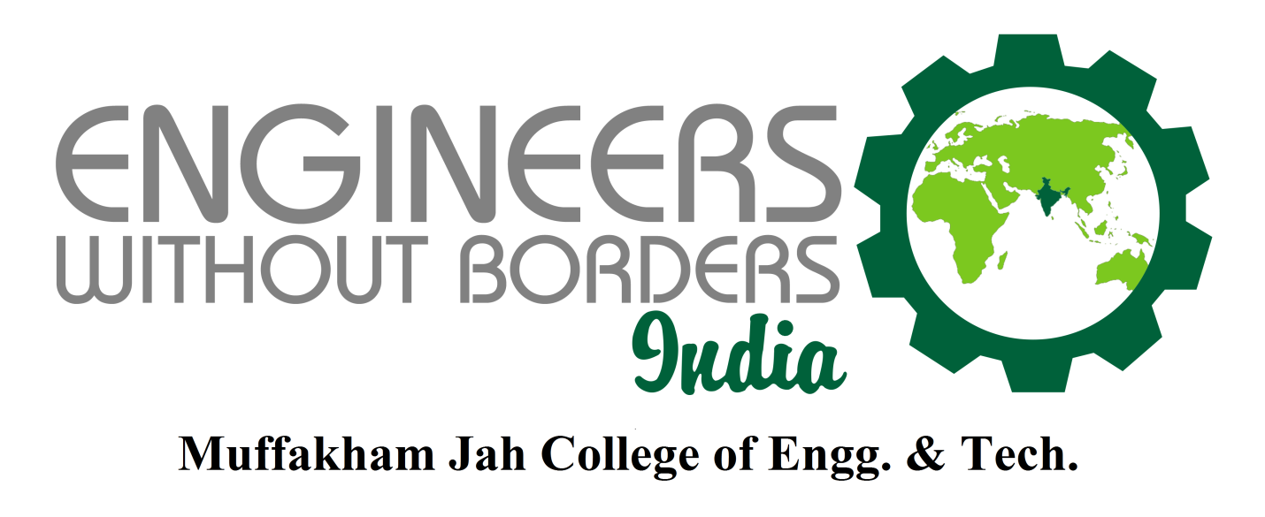

Road No. 3, Banjara Hills, Hyderabad, Andhra Pradesh, India

ENGINEERS WITHOUT BORDERS
MJCET STUDENT CHAPTER

Projects and Activities 2019-2020

EWB-MJCET Chapter was started in the year 2005 as the first student chapter of EWB-India and has been the most active student chapter in the country. It currently has 150 members.

EWB-INDIA MISSION
Our mission is driven by an urge and concern for accelerating sustainable rural development, assisting in capacity building in backward rural and urban communities of India, protecting the country's natural resource base and working across national boundaries for social and economic justice and responsible use of technology.
Faculty Advisors
1. Prof. Ishrat Meera Mirzana
2. Asst. Prof. N. B. V. Lakshmi Kumari
3. OFFICE BEARERS

President | R Sai Aakash Reddy
Vice President | Hadi Ali Farooqui
Secretary | Sohail
Joint Secretary | Shahid Salim Dhamani
Treasurer | Deeksha Rana

Awards & Achievements in 2019-2020
- EWB-MJCET has won the BEST CHAPTER AWARD, during EWB ALL CHAPTERS MEET in January 2019.
- EWB –MJCET Students were awarded as the Best Team for Volunteering for AIRTEL MARATHON which was organized by Airtel Tele-Services.
Events Conducted
1.TSE-2019 : An Conference was organized on 1,2 & 3 March 2019 at Seminar Hall ,MJCET.

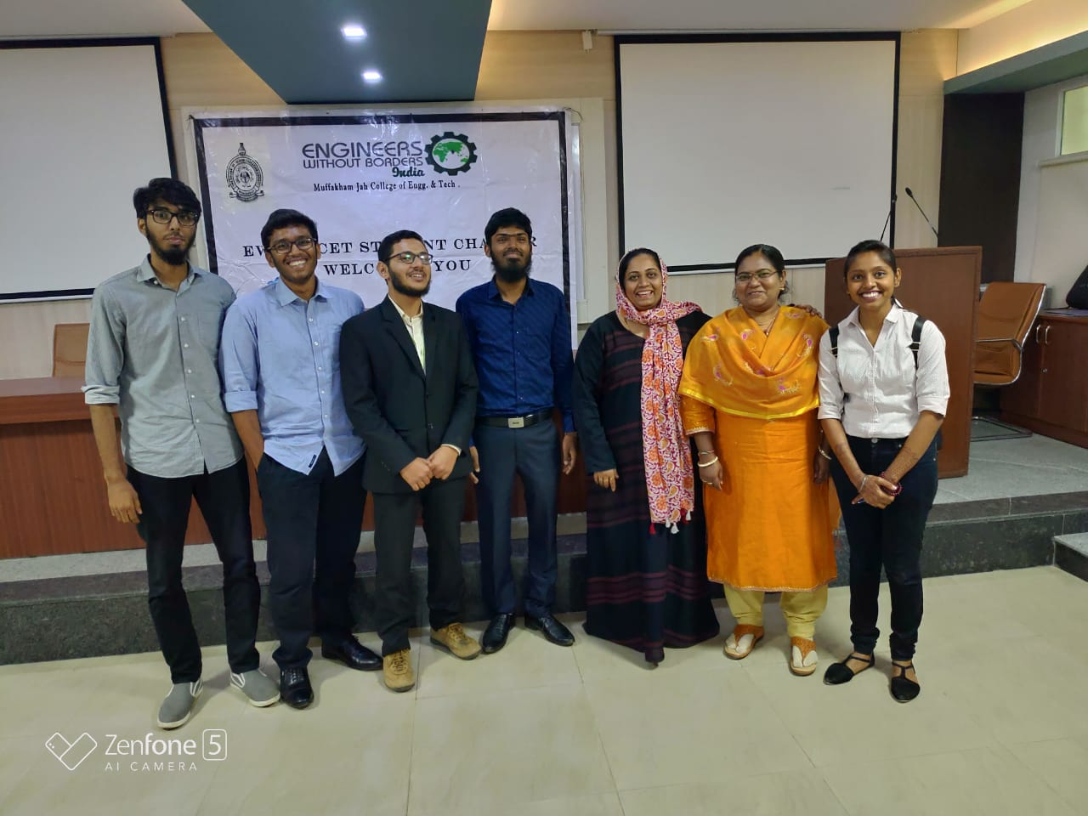
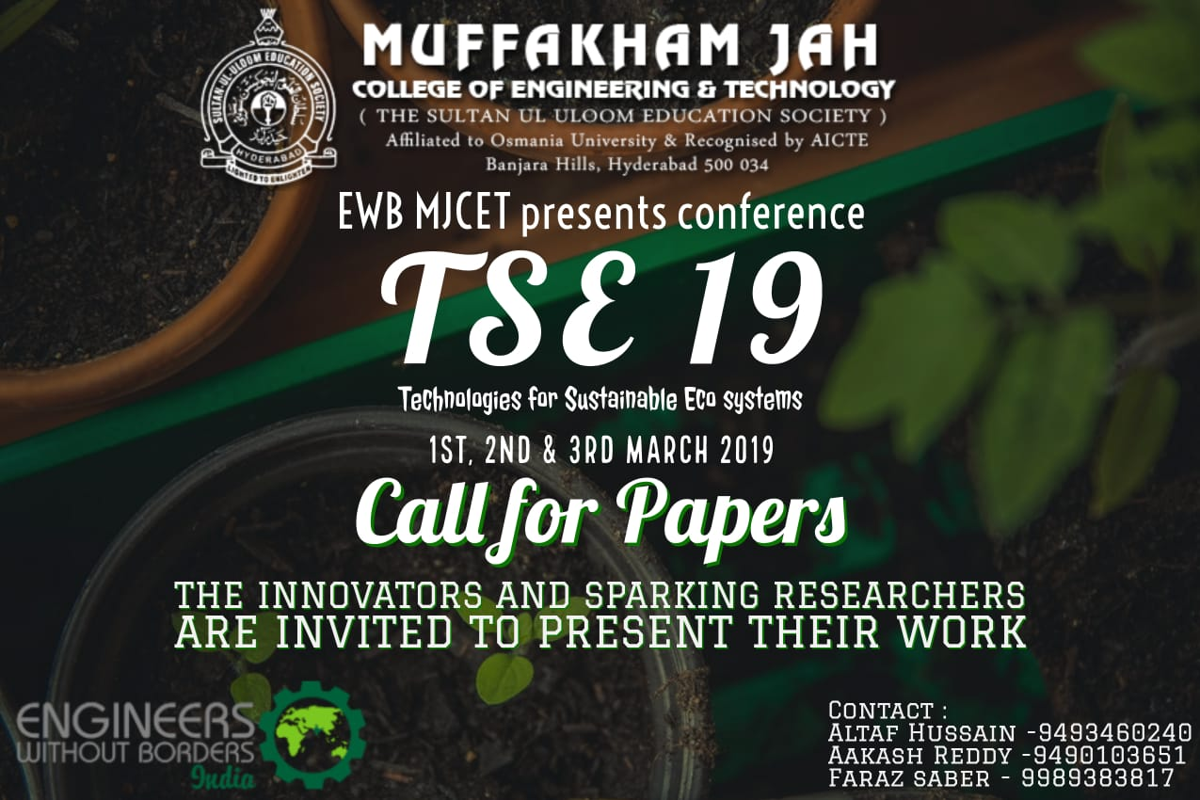

2.Airtel Marathon : The students of EWB-MJCET have volunterued for Airtel Marathon which was held on August 22, 2019.More than 50 students have participated for the event.

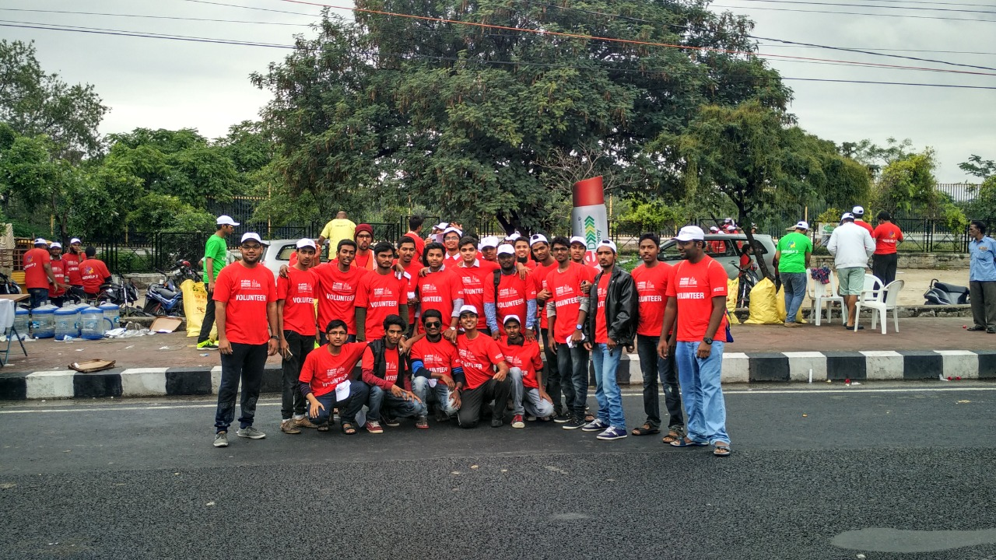

FACULTY ADVISOR
Dr.Ishrat Mirzana

